SPOKANE FALLS MONTESSORI

Infant ◊ Toddler ◊ Preschool ◊ Kindergarten
Spring 2024
Nature Walk Permission Slips  With warmer weather upon us, we will begin taking children on nature walks again soon. These are a special time where children get to explore our beautiful campus while watching for apple trees, turkeys, flowers, marmots, and other nature items. They learn names and concepts while exploring these things with all of their senses. We are very fortunate to have this amount of nature in our backyard!  Next week, we will place a permission slip for your child to take periodic walks around our campus (Mukagawa campus) with their classroom and teachers. Older children will walk with a buddy while younger children may ride in a stroller or the “Bye-bye buggy.” While are campus is monitored by Mukogawa maintenance and campus security, teachers are taking extra steps to ensure each child’s safety. Teachers have been instructed to limit interactions with strangers, including not giving personal information about children or allowing pictures to be taken (which we are sometimes approached by the Japanese students as they seem to adore your young children and will often ask for a photo). Additionally, staff will have a cell phone on them in case of an emergency, will notify another teacher or classroom before they leave, and will return immediately if they sense any safety issues. We are hopeful that these precautions will not be necessary but safety is our main priority.  Please sign and return the Nature Walk Permission Slip that will be placed in cubbies next week, as soon as possible. If you do not want your child to go on nature walks with their classroom, please simply write that on the slip, sign it, and return it to your child’s teachers.  From the PTO  Hello from the PTO!  Spring is here and we have some fun things coming up! Spirit Week is back by popular demand! Mark your calendars for April 15-19, theme days will be announced after Spring Break. Our Bloomsday fundraiser is also going to be back again this year and we'll need lots of help with items to sell, volunteers to help, and kids to cheer! Look out for more information mid-April. Teacher Appreciation Week is also around the corner, May 6-10th. PTO loves to spoil our teachers throughout the week! If you'd like to help plan or contribute monetarily, please email us at sfmspto19@gmail.com - THANK YOU!  If you would like to learn more about how you can get involved with the PTO or have any questions/ideas, please feel free to reach out - we'd love to hear from you!  Rachael McKinney (Marley's Mom), President  Renee Bursch (Oakley's Mom), Vice President  Tes Anderson (Will's Mom), Treasurer  Jenni Warren (Van's Mom), Secretary  **************FACEBOOK******************  Ask to join the private group, “Spokane Falls Montessori Parents and Teachers” and/or “like” the school’s public page. We post news, pictures and resources often! | Upcoming Dates  March 18-22  Toddler Parent/Teacher Conferences  School OPEN  March 25-27  Preschool Parent/Teacher Conferences  School OPEN  April 1-5  Spring Break  School Closed  May 27  Memorial Day  School Closed  June 19  Juneteenth  School Closed  June 21  Kindergarten Graduation/Pizza Party  School OPEN  July 4  Independence Day  School Closed  August 14-16  Compliance Days  School Closed  September 2  Labor Day  School Closed  
Teacher Spotlight  Each quarter a teacher will be chosen to highlight in our newsletter. Below is Georgia, a toddler room co-teacher.  How long have you worked at SFM?  About a year and a half.  What types of training/education/experience have you had in Early Childhood Education and/or Montessori?  Before working here, I worked with middle school students. I have fallen in love with this age group and plan to go to school for Early Childhood Education.  What do you love about teaching?  I love getting to make a difference, and watching children grow into new human beings!  What is your most memorable moment at SFM?  My most memorable moment was becoming a co-teacher. I love the in-depth parent communication, getting to do portfolios, assessments, and touching base in general about their child’s growth. I just love my job!  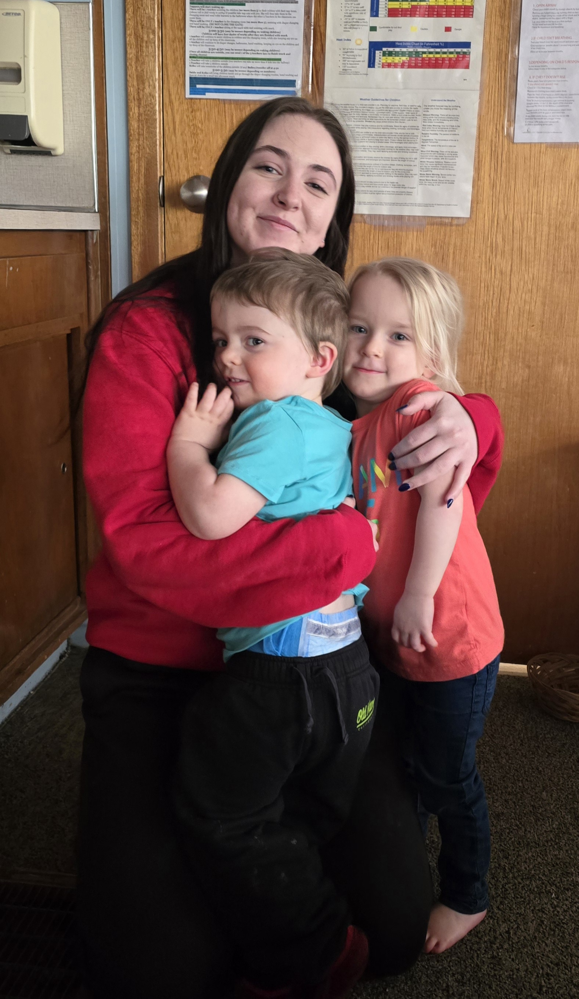 | CHECK IT OUT!  Volunteer Time  Did you know that in place of your annual 8 hours of volunteer time, you can sign up to bring 1 needed item per month from your child’s classroom? There are whiteboards placed near each sign-in area—check it out! Also, please see the Amazon Wish List Links below.  Preschool/Kinder:https://www.amazon.com/hz/wishlist/ls/2WND0CSWSLWG3?ref_=wl_share  Toddler:https://www.amazon.com/hz/wishlist/ls/3E2H7PZFKVLD4?ref_=wl_share  Infant:https://www.amazon.com/hz/wishlist/ls/4OCEVOX48912?ref_=wl_share  Leave-a-book-take-a-book  Many of you have already taken the opportunity to check out the book bin on the table near the main entrance. This is a great way to spread the love of reading, and it’s open to all ages--children and adults! Check it out!  Parent Resource Library  Looking for some parenting tips or just want to learn more about Montessori? Check out our resource library located in the glass case near the front entrance.

Infant Classroom  Happy Spring from the Infant Room.  In the last couple of months, we have welcomed new infants and said goodbye to many friends that have transitioned next door to the Toddler Room. We miss all our toddler friends but know that they are flourishing in their new wider world. We also said goodbye to our assistant teacher Charity and we welcomed Ellie as the new afternoon assistant in the Infant Room in her place. Ellie is in the process of moving from the Diamond Lake area to Spokane.  The school has also been hiring and training new substitutes. Many of us know Jackie well already. Chloe is one of our newest substitutes. We are so grateful to all our substitutes as they support all of the teachers in the school. Please thank them for all their help when you see them!  Soapy Biz!  For the most part, everyone is doing a great job remembering to wash hands, but we want to remind you to keep it up. Please wash your child’s hands and your own when entering the classroom as this really does impact the number of germs we bring into our environment.  Medications (Diaper Cream)  We have had some questions about medications lately. All medications must be brought in with a completed medication form (by the front door) and must follow our medication guidelines. Ask your child’s teacher for help with our licensing rules regarding medications. The medication then must be placed in a Ziplock baggie (with your child’s full name on it) and placed in the appropriate spot. Diaper cream can be left in the bin on the shelf above the diaper changing table. Please don’t leave medications without a form or in their backpack.  7 to 9:30 AM Arrival Policy  We have had a lot of questions lately about our 9:30 policy in the morning. This policy asks that every child arrive at school by 9:30. There are a lot of good reasons that we have this policy in each room. One of the main reasons that we have this policy in the Infant room is that it allows the whole classroom to run peacefully and smoothly. When children come in late:  1. They can awaken children already napping.  2. It is harder for the teachers to predict the care the late infant will need. Parents often ask, “How are you able to care for 4 infants at once?” Being able to predict and plan for when a child needs a nap, food, diaper change, or a hug is important in insuring that not all the children are hungry and tired at the same time.  3. The peace of the classroom is interrupted for a longer period of time. Almost all infants go through periods of separation anxiety. They need extra help and nurturing when they first arrive and their parents have to leave. If we have children arriving late, this increases the amount of time the classroom is experiencing separation anxiety together. When everyone is at school by 9:30, we are then able to transition to a peaceful working environment where we can focus exclusively on the children.  For this reason, we ask that you try to schedule as many doctor appointments in the afternoon as you can.  Once again, we all want to thank you for sharing your children with us. Let’s hope that the rest of the year brings health and joy to us all!  Thank you,  The Infant Room teachers. | Toddler Classroom  Welcome to Spring and Summer here in our toddler class!  Your toddlers have been a busy little bunch engaging in many learning experiences to foster their sensitive periods. We focused much of our time on practical life, self help and sensorial activities as well as opportunities to express their creativity, which helped ease us through the winter months. Your children continue to work tirelessly on simple sorting tasks, transfer works, spooning, pouring and wiping up spills. They enjoyed many “hands on” snack preparation experiences, such as making sandwiches, pouring food into bowls, cutting bananas and almost any other food prep that  your child can participate in. Some have mastered dressing themselves independently and others are working daily on these self help skills. We also dabbled in various forms of  artistic expression and have been working diligently on colors, shapes, numbers, and letters and recognizing their names.  “The education of even a small child, therefore, does not aim at preparing him for school, but for life.”  Maria Montessori  Now that spring is here, we have already been enjoying plenty of fun outdoors. We will soon be planting flowers and a small garden in our toddler yard and your toddlers will be  having a blast watering all the plants and watching them grow!  Hurray! Summer is just around the corner and we are gearing up for our summer curriculum with many planned activities out in our toddler yard and our beautiful  campus! Some of the areas of focus are nature, science, language, self help skills, and fine and gross motor development. The toddlers will enjoy taking walks, washing our cars and bikes, collecting rocks, sticks, feathers, and observing bugs and other animals. We will be taking a close look at nature and its changes. Our curriculum will expand on new experiences through language and practical life work to reflect the interests of the children, allowing several opportunities for open-ended exploration and spontaneous  discoveries.  “There must be provision for the child to have contact with nature; to understand and appreciate the order, the harmony and the beauty in nature...That the child may better understand and participate in the marvelous things which civilization creates”. Maria Montessori  CLASSROOM ASKS  We would like to ask our families if you have some egg containers and plastic bags that we could have. I’m sure you know what the plastic bags are for and we would like to start  a small indoor garden with the egg containers. Also, if you have any crib sheets you are no longer using, we would love to use them.  JUST A FEW REMINDERS  Our doors open at 7am, with a drop-off no later than 9:30, unless otherwise discussed and we promptly close at 5:30 pm.  We understand things come up and would like a courtesy call or text if there is going to be a change to your child’s drop-off times or pick-ups. Please reference your parent handbook for any late pick-up fees.  In closing, a quick reminder to:  - bring in sunscreen, if you have not already (with sun block form)  - replace winter spare clothing with spring/summer clothing  - bring in a swimsuit, water bottle, sun hat and towel for fun days in the sun and the  water  *PLEASE LABEL ALL ITEMS*  With as much independence and freedom with limits in our classroom, some of your children change many times a day and clothes get mixed up. Labeling all items would be  extremely helpful for all. Thank you so much for your help!  We appreciate all ideas and suggestions, so feel free to speak to Chrissi. We look forward  to an enjoyable summer with our families!  With love always, Chrissi, Taylor, Georgia, Maddie and Alondra | Preschool Classroom  The end of the school year is creeping up quickly, as always! The classroom is buzzing with children who know it! ☺ We are working on keeping focused on our work during this busy, exciting time of year.  Last month, Miss Kayla taught the children about concepts like community, kindness, and being a friend. They posted our classroom rules, and the children have now been reminding each other of “rule number 1, 2, 3, or 4” etc! It’s so great to hear the children recognize and recall their learning. This month Miss Julia is focusing on weather. They have been keeping track of the weather each day on their weather chart posted on the window. They are also learning about the different types of clouds, and will be learning more about the water cycle in the next few weeks. Next month Miss Kristin will be teaching the children about flowers. As we approach gardening season, we are always looking for parents who want to volunteer to help plant and care for our garden.  As it gets warmer, please check your child’s extra clothes bin and update it with warm weather clothes. Also, sunscreen permission forms will come out soon, as we will begin applying sunscreen in April. Remember to apply it in the morning and we will reapply it in the afternoon. Lastly, if you haven’t already, please bring a water bottle with your child’s name on it.  Coming soon we will be converting our bulletin board in the nap room to a family board! We will be asking for pictures of your child and their family to display on the board year-round. Children can show off their family, and other families can get a chance to see your family. We hope to create a more connected community by doing so. More information will be out soon!  A few reminders:  - Please remember to check labels on food items for snack, especially for sesame in items like bread and crackers.  - Please label all items, and remember to return borrowed items marked with SFM—we are running low!  - Please check your child’s communication cubby daily  - Please check the lost and found bin weekly  Miss Julia, Miss Kristin, Miss Kayla, Miss Sundi, Miss Kelly, Miss Mia, and Miss Emily

